CBOEdirect Connectivity for Hybrid

September 1, 2004

This document describes the application connectivity requirements for CBOEdirect for Hybrid. There are two APIs that may be used with CBOEdirect, FIX 4.2 and CMi 2.5. The application connectivity for each API is shown in Figure 1. The connections to the MDCAS servers are required for market data and for expected opening price / size information. If the Firm does not need or want this information, these connections are not required. Tables 1 and 2 list the specific IP addresses and ports for each service for the two APIs.

Figure 1 FIX and CMi Application Connectivity for Hybrid

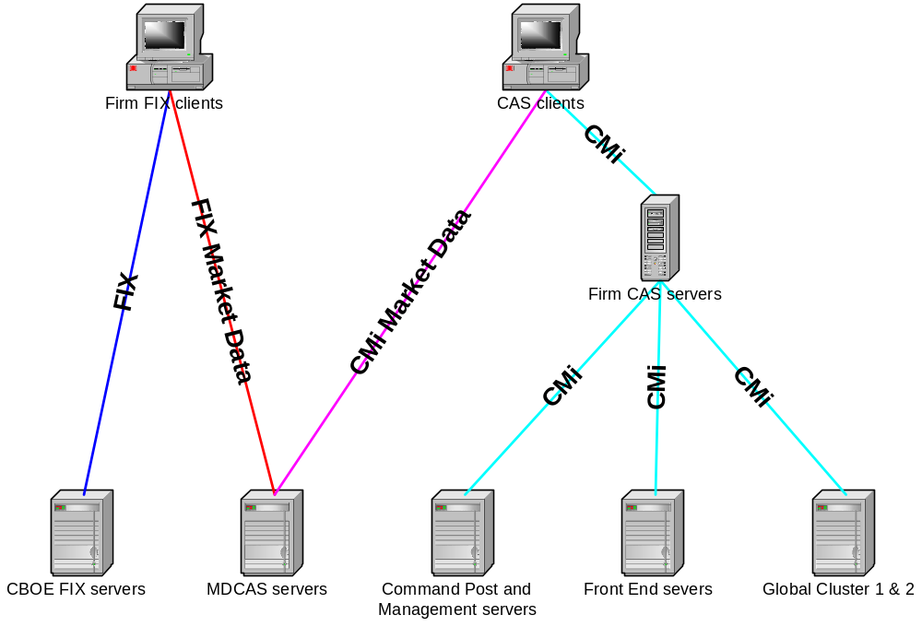

Table 1: IP Addresses and Ports for CMi

Source IP | Destination IP | Protocol/Port | Service | Comment
Firm CAS servers | CAS clients | TCP/22 | SSH | CBOE Trader Workstation Clients Only
Firm CAS servers | CAS clients | TCP/8101 | Client ORB | Ports(s) determined by client ORB configuration
Firm CAS servers | CAS clients | ICMP | Ping
Firm CAS servers | Front End servers  170.137.93.3  170.137.93.4  170.137.93.10  170.137.93.11  170.137.93.21  170.137.93.22 | UDP/123 | NTP
Firm CAS servers |  | TCP/5101 | RT server
Firm CAS servers |  | TCP/18005 | FE ORB
Firm CAS servers |  | TCP/18023 | FE ORB v2.0
Firm CAS servers |  | TCP/18081 | SMS proxy
Firm CAS servers |  | TCP/18136 | Process Watcher
Firm CAS servers |  | ICMP | Ping
Firm CAS servers | Global Cluster 1  170.137.93.18  170.137.93.19 |  |  | all ports closed 4/13/04
Firm CAS servers | Global Cluster 2  170.137.93.6  170.137.93.7 | TCP/18026 | TraderService
Firm CAS servers | Global Cluster 2  170.137.93.6  170.137.93.7 | TCP/18027 | InterfaceRepository
Firm CAS servers | Global Cluster 2  170.137.93.6  170.137.93.7 | TCP/18028 | LocatorService
Firm CAS servers | Global Cluster 2  170.137.93.6  170.137.93.7 | TCP/18029 | ChannelAdmin
Firm CAS servers | Global Cluster 2  170.137.93.6  170.137.93.7 | TCP/18030 | SecurityService
Firm CAS servers | Global Cluster 2  170.137.93.6  170.137.93.7 | TCP/18031 | SecurityAdminService
Firm CAS servers | Global Cluster 2  170.137.93.6  170.137.93.7 | TCP/18032 | CentralRepository
Firm CAS servers | Global Cluster 2  170.137.93.6  170.137.93.7 | TCP/18055 | CentralLogging
Firm CAS servers | Global Cluster 2  170.137.93.6  170.137.93.7 | TCP/18062 | TranTimingRegistration
Firm CAS servers | Global Cluster 2  170.137.93.6  170.137.93.7 | TCP/18115 | IFR / NonRepudiation
Firm CAS servers | Global Cluster 2  170.137.93.6  170.137.93.7 | TCP/18136 | Process Watcher
Firm CAS servers | Global Cluster 2  170.137.93.6  170.137.93.7 | ICMP | Ping
Firm CAS servers | Management Servers  170.137.7.1  170.137.7.2  170.137.7.3 | ICMP | Ping | added 4/8/04
Other Firm Site | Management Servers | TCP/49 | TACACS+
CBOE equipment (switches, test PC, terminal server) | 170.137.4.55  170.137.5.55 | ICMP | Ping
CBOE equipment (switches, test PC, terminal server) | Management Server  170.137.5.29 | UDP/162 | SNMP Trap
CBOE equipment (switches, test PC, terminal server) | Management Server  170.137.5.29 | UDP/514 | Syslog
CBOE equipment (switches, test PC, terminal server) | Management Server  170.137.5.29 | ICMP | Ping
CBOE equipment (switches, test PC, terminal server) | Management Servers  170.137.7.1  170.137.7.2  170.137.7.3 | ICMP | Ping | added 4/8/04
Source IP | Destination IP | Protocol/Port | Service | Comment
CAS Clients  (trader workstation, firm autoquoter, etc.) | Firm CAS Servers | TCP/8003 | HTTP primary
CAS Clients  (trader workstation, firm autoquoter, etc.) | Firm CAS Servers | TCP/8004 | HTTP secondary
CAS Clients  (trader workstation, firm autoquoter, etc.) | Firm CAS Servers | TCP/8102 | CAS ORB primary
CAS Clients  (trader workstation, firm autoquoter, etc.) | Firm CAS Servers | TCP/8103 | CAS ORB secondary
CAS Clients  (trader workstation, firm autoquoter, etc.) | Firm CAS Servers | ICMP | Ping
CAS Clients  (trader workstation, firm autoquoter, etc.) | MDCAS servers  170.137.93.8  170.137.93.9  170.137.93.91  170.137.93.92  For future use:  170.137.93.93-100 | TCP/8102 | CAS ORB primary
CAS Clients  (trader workstation, firm autoquoter, etc.) |  | TCP/8103 | CAS ORB secondary
CAS Clients  (trader workstation, firm autoquoter, etc.) |  | ICMP | Ping
MDCAS servers  170.137.93.8  170.137.93.9  170.137.93.91  170.137.93.92  For future use:  170.137.93.93-100 | CAS Clients | TCP/8101 | Client ORB | Ports(s) determined by client ORB configuration
 | CAS Clients | ICMP | Ping
Front End Servers  170.137.93.3  170.137.93.4  170.137.93.10  170.137.93.11  170.137.93.21  170.137.93.22 | Firm CAS Servers | TCP/22 | SSH
 | Firm CAS Servers | TCP/8203 | CAS ORB
 | Firm CAS Servers | TCP/18039 | Sysman agent primary
 | Firm CAS Servers | TCP/18099 | Sysman agent backup
 | Firm CAS Servers | TCP/18136 | Process Watcher
 | Firm CAS Servers | ICMP | Ping
 | Other Firm site CBOE equipment (switches, test PC, terminal server) | TCP/22 | SSH
 |  | TCP/23 | Telnet
 |  | ICMP | Ping
Global Cluster 1  170.137.93.18  170.137.93.19 | Firm CAS Servers |  |  | All ports closed 4/13/04
Global Cluster 2  170.137.93.6  170.137.93.7 | Firm CAS Servers | TCP/22 | SSH
Global Cluster 2  170.137.93.6  170.137.93.7 | Firm CAS Servers | TCP/8203 | CAS ORB | added 8/13/04
Global Cluster 2  170.137.93.6  170.137.93.7 | Firm CAS Servers | ICMP | Ping
Command Post servers  170.137.5.33  170.137.5.34 | Firm CAS Servers | TCP/3181 | Patrol
Command Post servers  170.137.5.33  170.137.5.34 | Firm CAS Servers | ICMP | Ping
Management server  170.137.5.29 | Other Firm site CBOE equipment (switches, test PC, terminal server) | TCP/23 | Telnet
Management server  170.137.5.29 |  | UDP/161 | SNMP
Management server  170.137.5.29 |  | TCP/8200 | HTTP
Management server  170.137.5.29 |  | ICMP | Ping
Management servers  170.137.7.1  170.137.7.2  170.137.7.3 | Firm CAS servers | UDP/161 | SNMP | added 9/1/04
Management servers  170.137.7.1  170.137.7.2  170.137.7.3 | Firm CAS servers | ICMP | Ping
Management servers  170.137.7.1  170.137.7.2  170.137.7.3 | Other Firm site CBOE equipment (switches, test PC, terminal server) | ICMP | Ping

Table 2: IP Addresses and Ports for FIX

Source IP | Destination IP | Protocol/Port | Service | Comment
Firm FIX clients | CBOE FIX servers  170.137.93.x | TCP/x | FIX 4.2 | Each Firm is assigned to one or more FIX Servers with unique IP and port numbers
Firm FIX clients | CBOE FIX servers  170.137.93.x | ICMP | Ping
Firm FIX clients | MDCAS servers  170.137.93.8  170.137.93.9  170.137.93.91  170.137.93.92  For future use:  170.137.93.93-100 | TCP/21536 | FIX 4.2 | Market Data Only
Firm FIX clients |  | TCP/21537 | FIX 4.2 | Market Data Only
Firm FIX clients |  | ICMP | Ping
CBOE FIX servers  170.137.93.x | Firm FIX clients | ICMP | Ping
MDCAS servers  170.137.93.8  170.137.93.9  170.137.93.91  170.137.93.92  For future use:  170.137.93.93-100 | Firm FIX clients | ICMP | Ping

